REVA

UNIVERSITY

**Bengaluru, India**

**SCHOOL OF COMPUTING AND INFORMATION TECHNOLOGY**

PROJECT REPORT ON

“STUDENT HOMEPAGE”

Submitted in fulfilment of the requirements for the award of the Degree of

BACHELOR OF TECHNOLOGY IN

COMPUTER SCIENCE AND INFORMATION TECHNOLOGY

**Submitted by**

(R20EJ042)

(R20EJ003)

(R20EJ010)

SEJAL SINGH

ADITYA KUMAR

BAANI MALIK

Under the guidance of

**PROF. PAVAN KUMAR NAIK**

Prof., School of CIT  
REVA University

**DECLARATION**

We, **SEJAL SINGH, ADITYA KUMAR, BAANI MALIK,** students of B.Tech, School of Computing and Information Technology, REVA University, to declare that this project Report entitled **“STUDENT HOMEPAGE”** is the result of the project work done by us under the supervision of Prof. Pavan Kumar Naik Prof., School of CIT, REVA University, Bengaluru.

We are submitting this Project Report in partial fulfilment of the requirements of Bachelor of Technology in Computer Science and Information Technology by the REVA University, Bengaluru during the academic year 2022-2023.

**ABSTRACT**

A student portal is a website that contains all the required information that a student may need during their school years, As more and more of our life is transacted online, expectations grow about what services are offered from a college or university and how they are delivered.

Whether you are enrolling a new student or supporting a current student, a portal is a cornerstone technology for delivering the content, applications, and services needed to be successful.

A student portal is a commonly used phrase to describe the login page where students can provide a username and password to gain access to an education organization’s programs and other learning related materials.

**TABLE OF CONTENTS**

**Table of Contents**

**Chapter 1: Introduction**

1.1 Introduction

1.2 Student Homepage Definition

1.3 Background of Study

1.4 Objective of project

1.5 Scope of project

**Chapter 2: Problem Definition**

2.1 Definition

2.2 Form Design

2.3 Home Page

2.4 About Page

2.5 Campus Page

2.6 Faculty Page

2.7 Achievements Page

2.8 Contact Page

**Chapter 3: Requirement Gathering /Analysis**

3.1 Requirement Analysis

3.2 Software Requirements

3.3 User Requirements

3.4 Functional Requirements

**Chapter 4: Conclusion**

4.1 Conclusion

**Chapter 1**

**1.1 Introduction**

A student portal is a commonly used phrase to describe the login page where students can provide a username and password to gain access to an education organization’s programs and other learning related materials. Sometimes a student portal also refers to the entire student-facing part of a learning management system (LMS).

A learner who has enrolled in an online certification program, for example, may use a student portal to access online course materials that are hosted on the school’s servers, such as articles, lectures and videos. Student portals may be used to provide information about the school, course details, calendars, academic resources, and contact information.

Some student portals may integrate with other systems to provide students with easy access to personal information, such as tracking financial aid disbursements and using campus medical services.

**1.2 Student Homepage Definition?**

A student portal is an online gateway where students can log into a school website to access important program information. Student portals also contain information on the organization, campus, faculty, achievements, and department contact numbers.

**1.3 Background of Project**

Background of the project Student Homepage, A student portal is usually part of a broader LMS that can also be used by parents and faculty members. This system is also usually built and managed in-house by the college/university, school district, or private educational institution. Students typically use their school-provided email address or student ID number to access the portal, and sometimes additional layers of authentication are required to verify the student’s identity.

**1.4 Objective of the project**

A student portal is essential in a digital-first education environment. As referenced above, it centralizes all school-related announcements, information, and resources. Students can keep up with assignments, course material, grades, and announcements from the same place, so it also enables students to take care of all school-related needs from a single location, which means students have fewer accounts to manage. This ultimately benefits campus-wide cybersecurity because it minimizes the opportunities for a malicious actor to intercept a student’s login credentials.

**1.5 Scope of The Project**

A student portal provides an engaging student experience with a single point of access and hub to all applications, information, and content. One of the biggest obstacles that a student portal removes is the number of information silos found across colleges and universities today.

**Chapter 2: Problem Definition**

**2.1 Definition**

A student portal project that acts as an online portal between students and the admin. The system is designed for Majority of the Universities. It contains an admin who can enter details of students. Students can then login using provided user id password and edit their profile details and image.

**2.2 Form Design**

This section describes form those are used into the system

**2.3 Home Page**

A home page or a start page is the initial or main web page of a website or a browser. The initial page of a website is sometimes called main page as well. It contains links to all the other pages.



**2.4 About Page**

The primary purpose of an about us page is to inform the reader about the company and its operations



**2.5 Campus Page**

This page contains the pictures of the campus







**2.6 Faculty Page**

This page contains information about the faculty.



**2.7 Achievement Page**

This page contains information about the achievements.



**2.8 Contact Page**

Students can leave messages and contact the university.

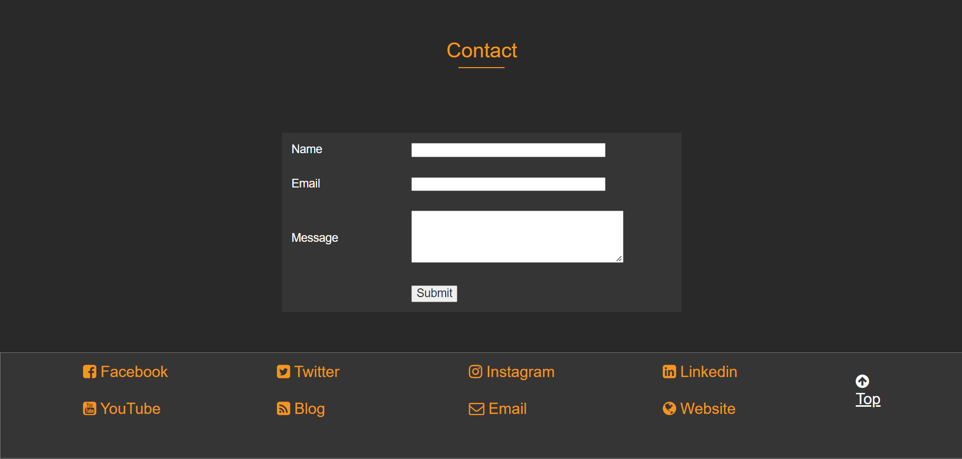

**Chapter 3: Requirement Gathering/Analysis**

**3.1 Requirement Analysis**

Requirements analysis in systems engineering and software engineering, encompasses those tasks that go into determining the needs or conditions to meet for a new or altered product or project, taking account of the possibly conflicting requirements of the various stakeholders, analysing, documenting, validating, and managing software or system requirements. Requirements analysis is critical to the success or failure of a systems or software project. The requirements should be documented, actionable, measurable, testable, traceable, related to identified business needs or opportunities, and defined to a level of detail sufficient for system design.

**3.2 Software Requirement**

* Software: Sublime Text, Visual Studio
* Compatible operating system: Windows, Mac
* Frontend design tool: Html, CSS, Java script

**3.3 User Requirement**

To deliver the best service to the users we tried to find out the user’s necessities which are below:

**Administrator Aspect:**

* Monitoring the whole system from admin panel.
* Taking back up of the database.
* Creating, deleting, and modifying the records.
* Add users for the admin panel.
* Add customers and other staff.
* Keeping the customer’s record like their details.
* Organizing their member registration system.
* Monitoring the transaction system.

**Customer Aspect:**

* Signing in and signing up to the system.
* Changing their password.
* Resetting forgot password.

**3.4 Functional Requirement**

In Software engineering and systems engineering, a functional requirement defines a function of a system or its component. A function is described as a set of inputs, the behaviour, and outputs. Functional requirements may be calculations, technical details, data manipulation and processing and other specific functionality that define what a system is supposed to accomplish. Behavioural requirements describing all the cases where the system uses the functional requirements are captured in use cases.

Functional requirements are supported by non-functional requirements which impose constraints on the design or implementation. Generally, functional requirements are expressed in the form "system must do ", while non-functional requirements are "system shall be ". The plan for implementing functional requirements is detailed in the system design.

As defined in requirements engineering, functional requirements specify results of a system. This should be contrasted with non-functional requirements which specify overall characteristics such as cost and reliability. Functional requirements drive the application architecture of a system.

**Chapter 4: Conclusion**

**4.1 Conclusion**

A student portal is a website that contains all the required information that a student may need during their school years, As more and more of our life is transacted online, expectations grow about what services are offered from a college or university and how they are delivered.

**4.2 Limitations**

For upcoming improvement, there are some proposals to advance our project abilities.

* There is no further detailed information
* There is no response system for the questions posed by the students
* There is no courses available page
* There is no actually working link